**Company Name: MOOMA TECHNOLOGIES PRIVATE LIMITED**

**Work Name: DAIRY MILK AUTOMATED SYSTEM**

**Lab Name : IoT Lab**

**Technical Details:**

IoT Sensor Integration: Installation of Sensors to measure milk volumes, milk quality, cow health parameters to enable remote farmer activity and dairy farm performance monitoring.

**Outcome:**

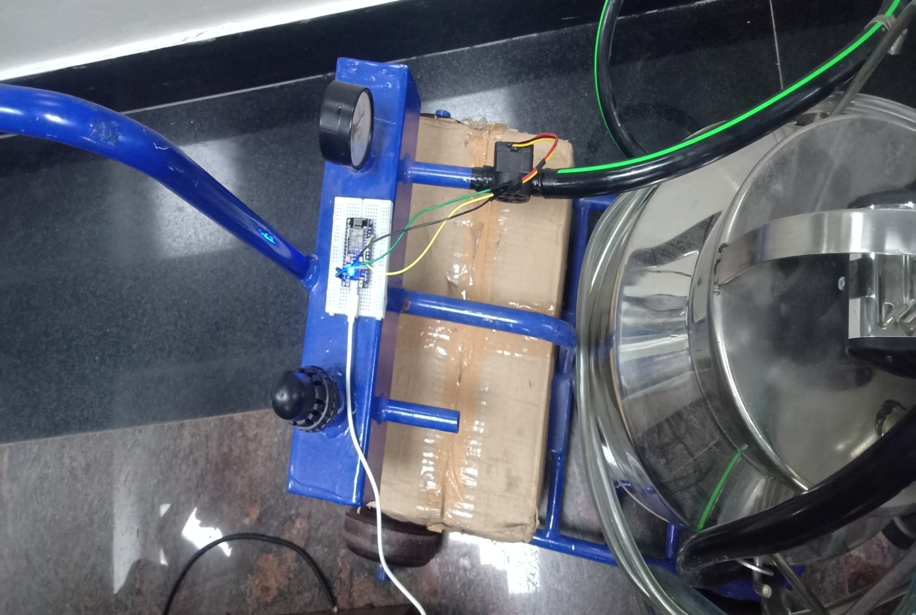

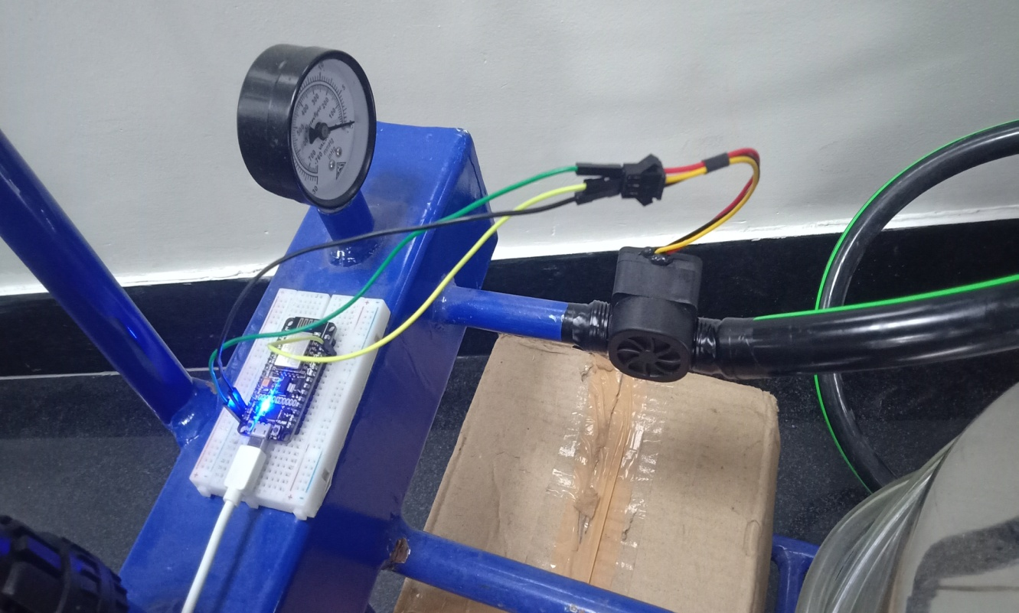

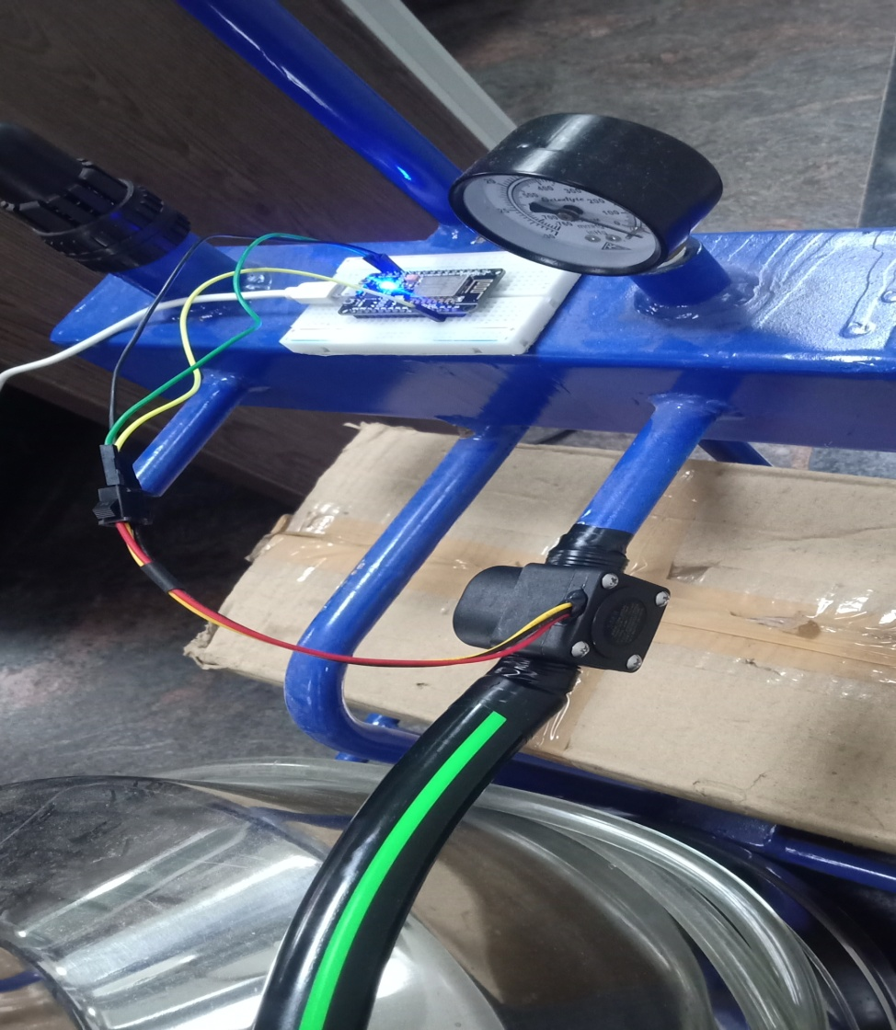

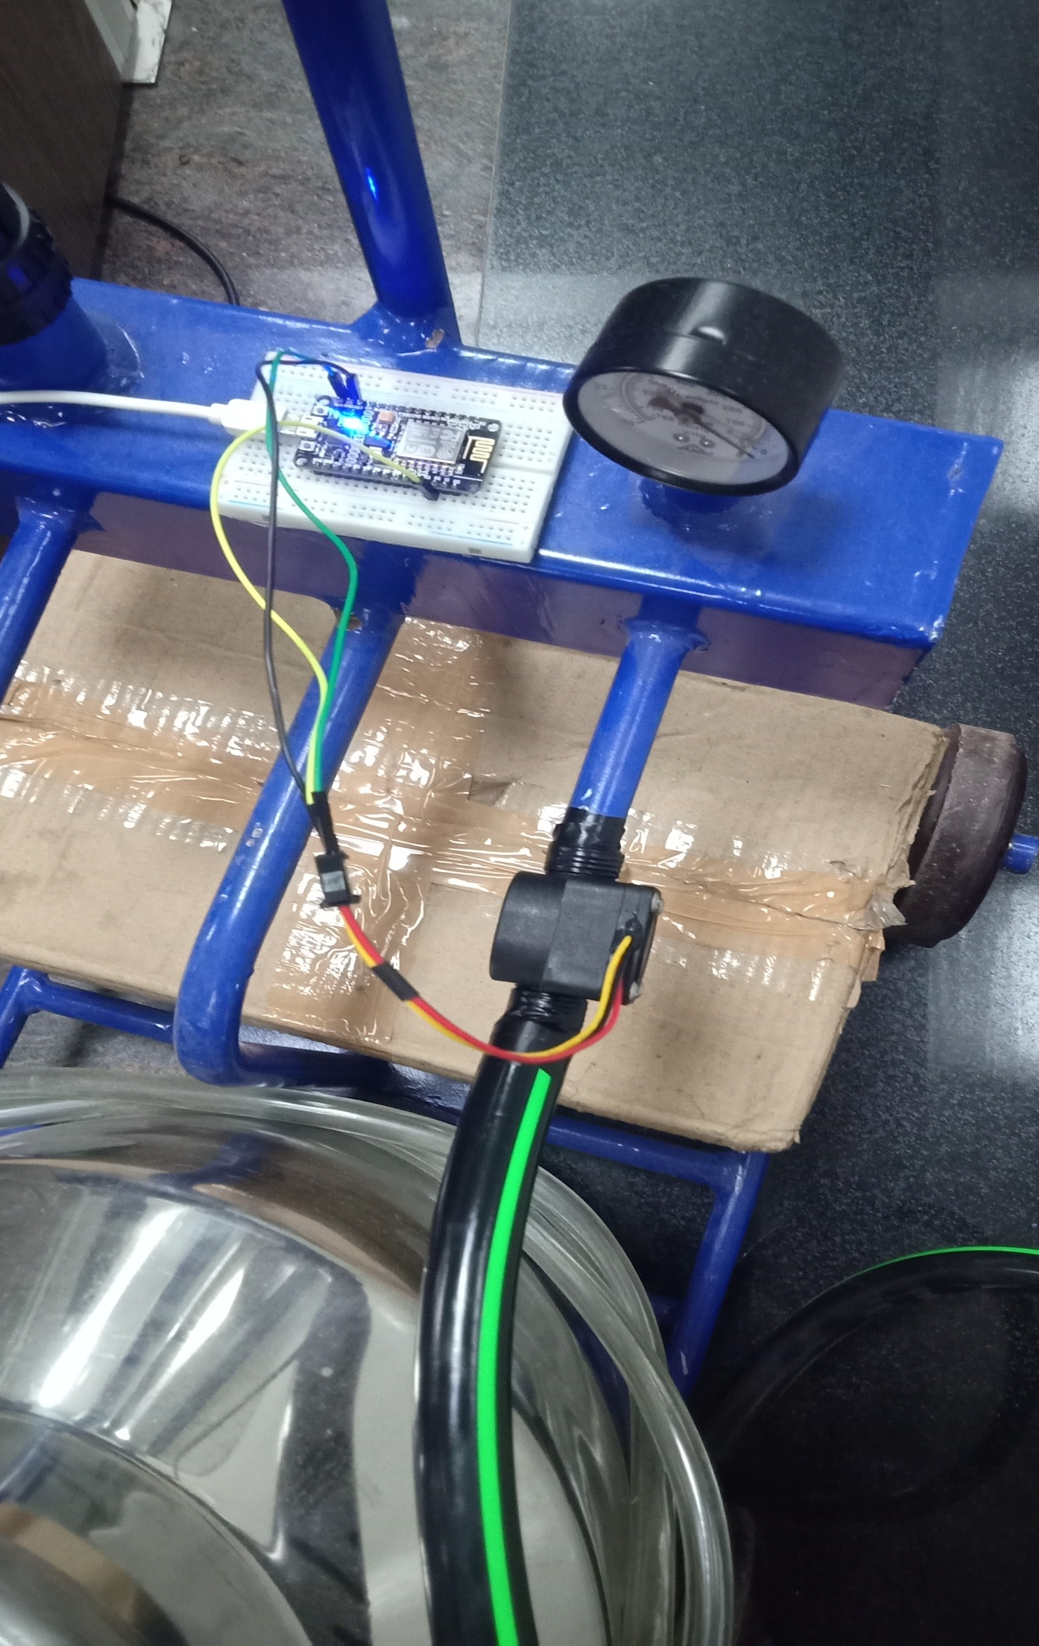

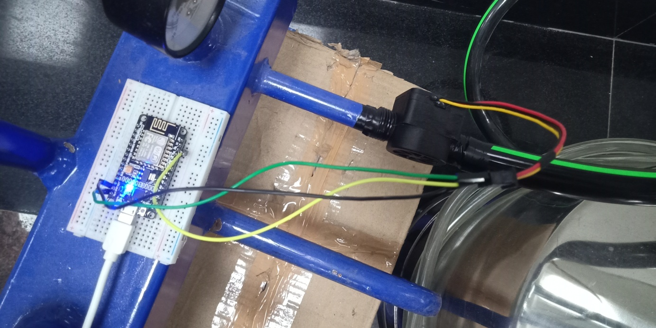

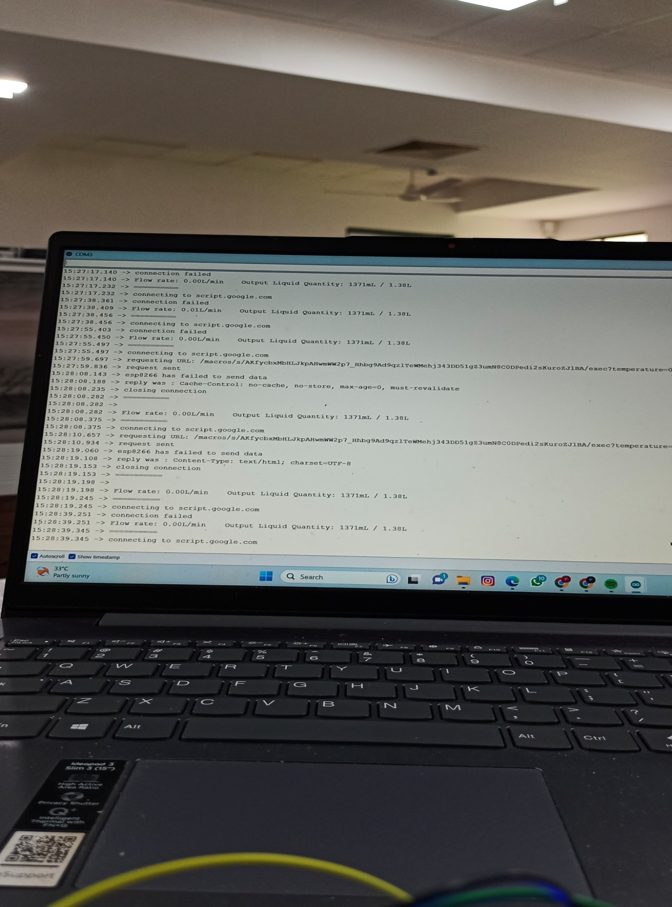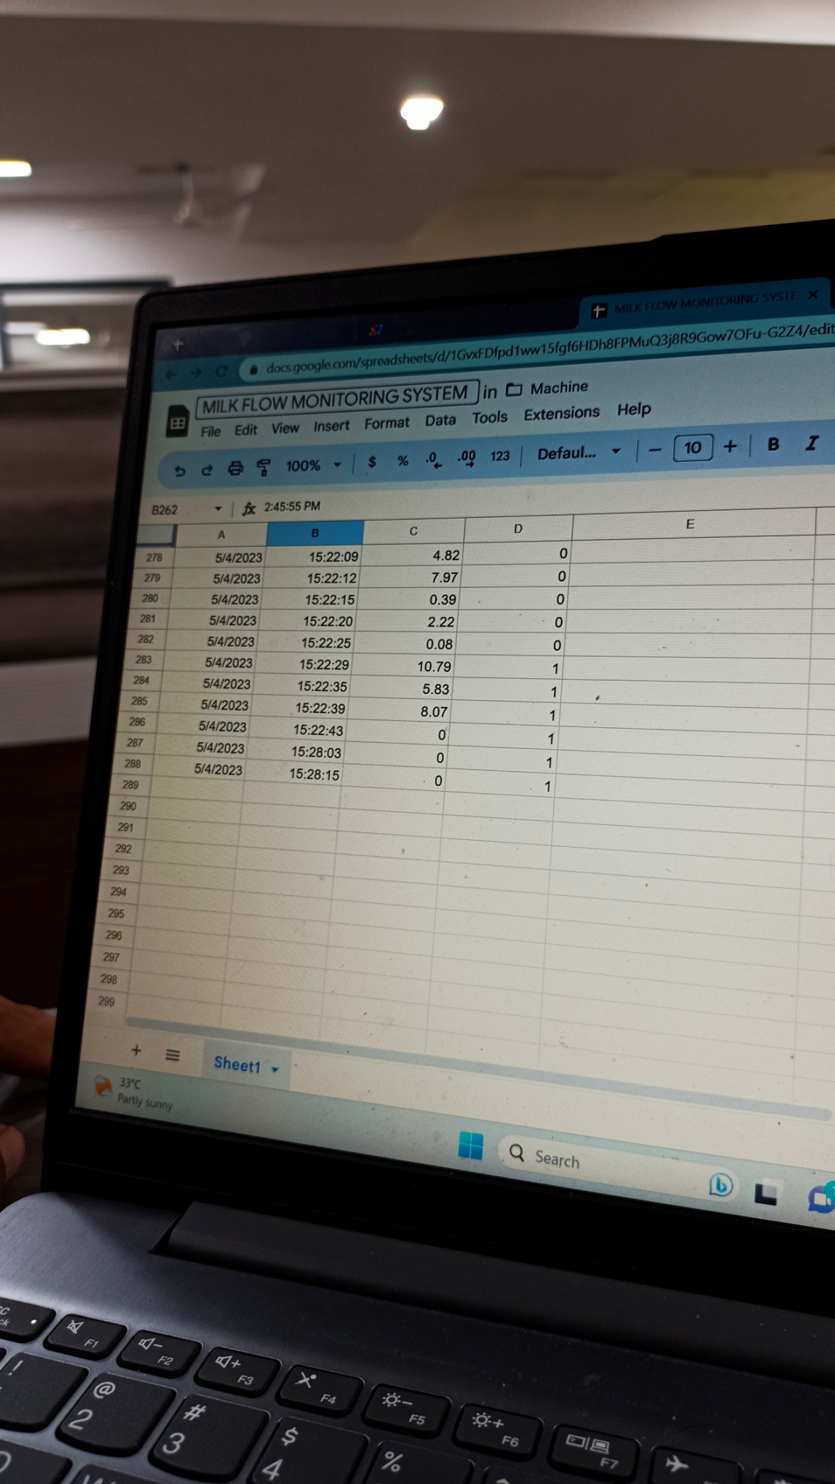

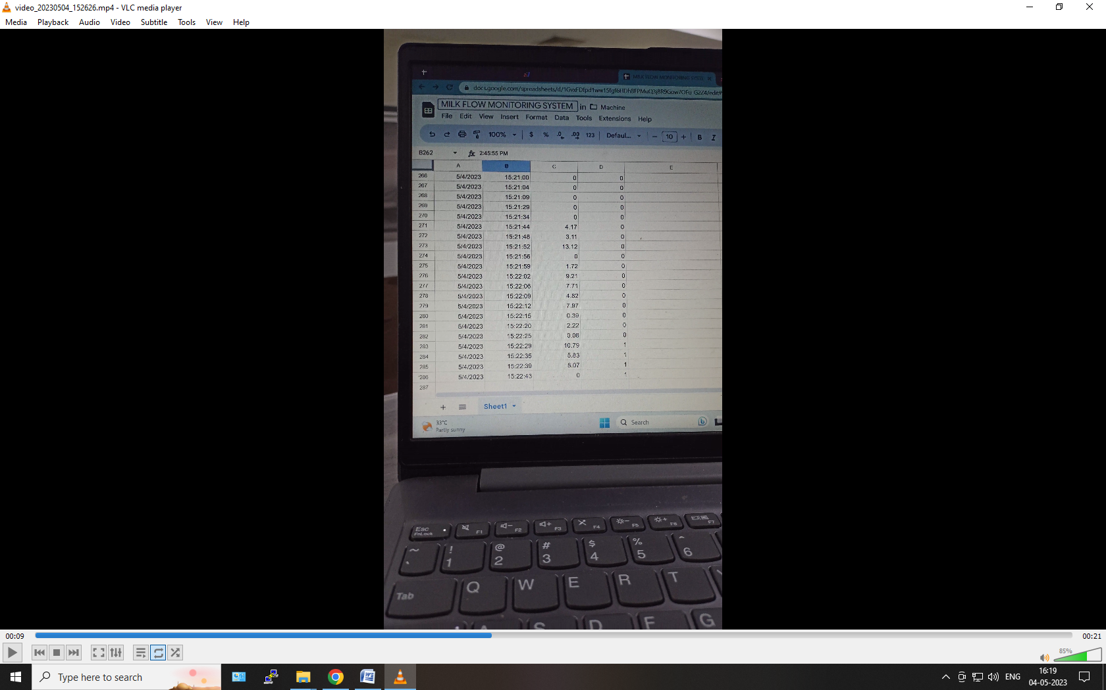

**Introduction:**

The integration of Internet of Things (IoT) sensors onto dairy farms has revolutionized the way milk volume, milk quality, and cow health are monitored. The installation of various sensors, including milk volume sensors, milk quality sensors, and cow health sensors, enables remote monitoring and real-time data collection, leading to improved efficiency, safety, and cost savings. This report highlights the benefits and applications of IoT sensor integration for dairy farms and the steps involved in its implementation.

**Benefits of IoT Sensor Integration:**

IoT sensor integration offers several benefits for dairy farms, including:

Remote monitoring: With IoT sensors, milk volume, milk quality, and cow health parameters can be monitored remotely, enabling farmers to keep track of their herd and make informed decisions.

Early detection of health issues: Cow health sensors can detect health issues early, allowing for timely intervention and treatment that can prevent disease spread and minimize animal suffering.

Optimized milk production: With milk volume and quality sensors, milk production can be optimized, leading to increased profits and improved herd management.

**Applications of IoT Sensor Integration:**

IoT sensor integration can be applied in various areas of dairy farming, including:

Milk volume monitoring: Milk volume sensors can be installed on milking machines to monitor milk production in real-time, enabling farmers to identify issues that can affect milk yield.

Milk quality monitoring: Milk quality sensors can be used to measure the quality of milk, including fat and protein content, somatic cell count, and other parameters that affect milk quality.

Cow health monitoring: Cow health sensors can be used to monitor various health parameters, including body temperature, rumination, and activity levels, enabling early detection of health issues.

**Steps Involved in IoT Sensor Integration:**

The implementation of IoT sensor integration involves the following steps:

Sensor selection: Determine the type of sensors required based on the milk volumes, milk quality, and cow health parameters to be monitored.

Sensor installation: Install the sensors onto the milking machines and cows and ensure that they are properly configured.

Data collection: Collect data from the sensors in real-time and store it in a database or cloud platform.

Data analysis: Analyze the collected data using data analytics tools and algorithms to identify trends, patterns, and anomalies.

Visualization: Visualize the data in a user-friendly dashboard or interface that provides real-time insights and alerts.

**Conclusion:**

IoT sensor integration is transforming the way milk volumes, milk quality, and cow healths are monitored on dairy farms. By installing various sensors onto milking machines and cows, real-time data collection and analysis can be conducted remotely, leading to improved efficiency, safety, and cost savings. As the technology continues to evolve, IoT sensor integration is expected to become even more ubiquitous, providing unprecedented insights into dairy farm performance and leading to even greater advancements in industry and society as a whole.